I’ve completed the first three modules, but only the Basic Interaction is Green.
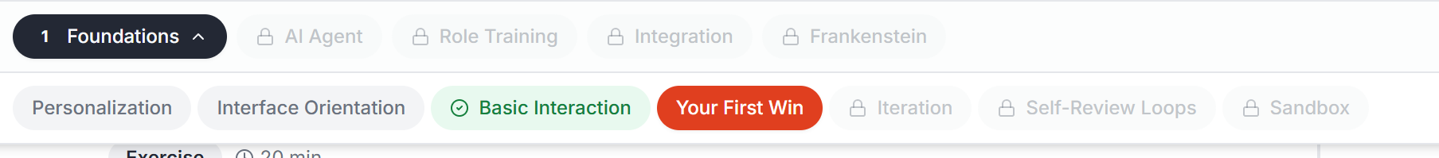
Upon clicking Continue on the dashboard, the user should be taken to the module that they furthest along their learning path. Currently it takes the user to the first module in the first session.
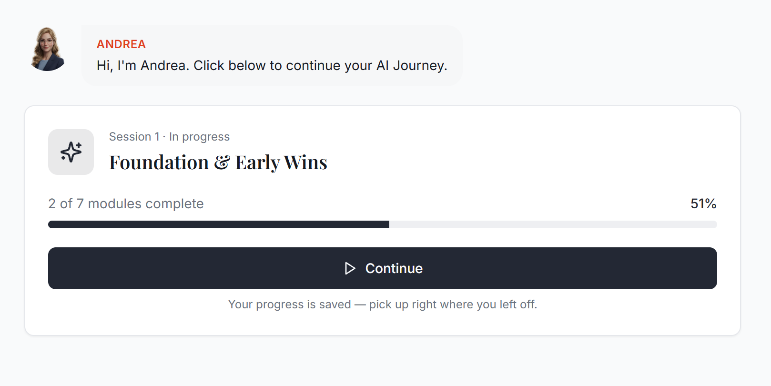
The user has completed 3 modules, but its only showing that two are complete.

Every time I navigate away from the web app, it reloads the current page. The existing page should persist and not require reloading.
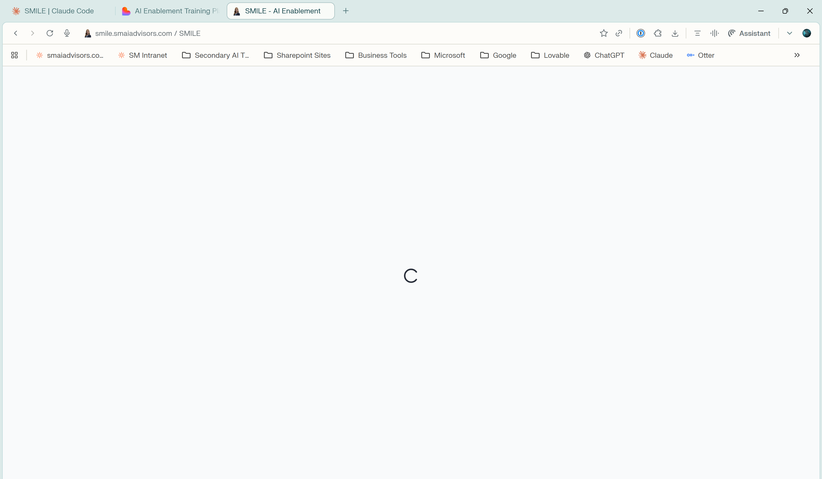
The percent completion in the dashboard doesn’t make sense. If 2 of 7 are complete, it should equal 2 divided by 7.
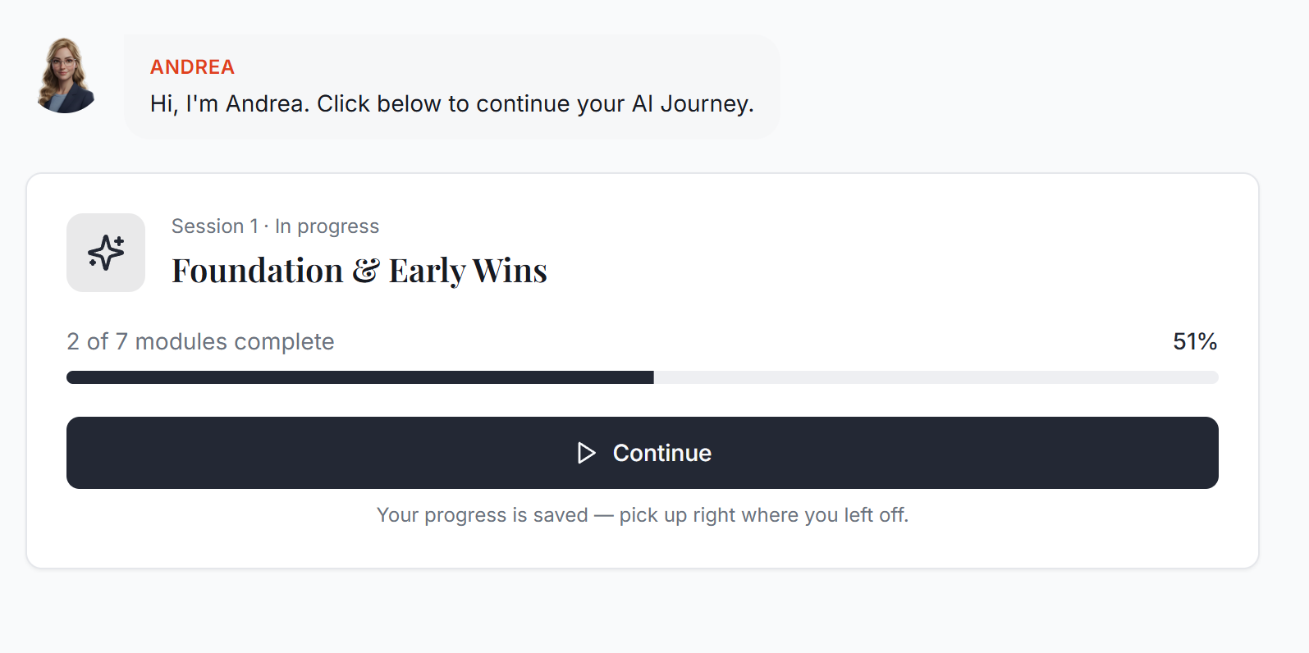
When dictation is turned on, the microphone just shows red with a line through it. I want the user to be able to see the transcription occur in the message during the dictation, so they know its working.
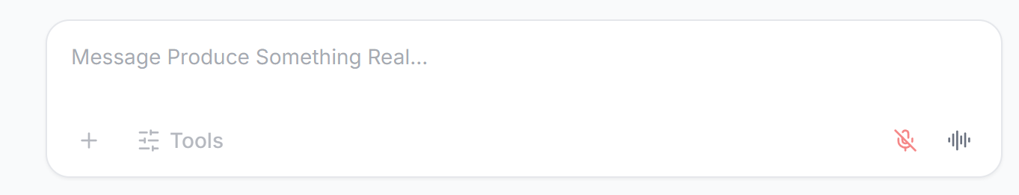
I got to the end of the Your first win module (1.4) and was told “Great Work! Continue”. It did move me to the Iteration tab, but the Andrea Chat didn’t reset and I just see the normal chat in the left pane – but no instructions on what to do.
